Find the busiest and quietest days in the month

To find the busiest and quietest day oin the month we have to follow next steps:

- Click on the tab Agenda

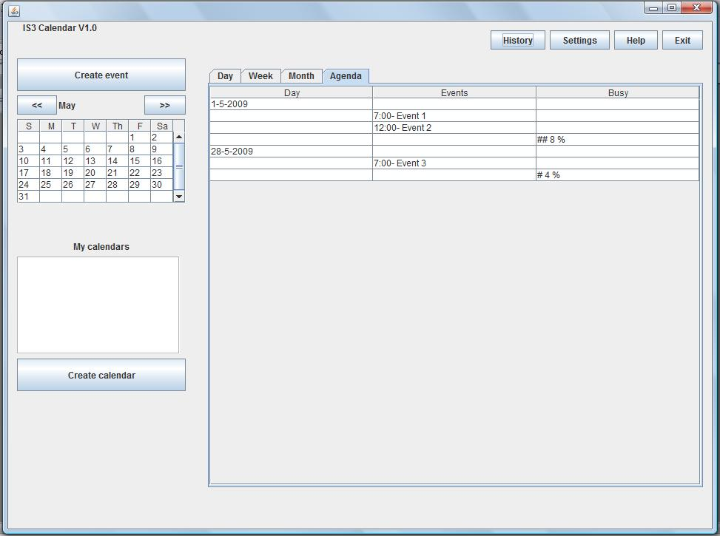
- User will get something like previous imagen in where he will be able to see all the events during a year. These events are ordered by ascendent date and in the busy column, he will be able to see a percentage indicating the total busy hours. Higher percentage busier day.
Set different categories for university, social and job appointments
To set a different category for different kind of events user must create new calendars to organise the information following next steps:

- Click on create calendar button.
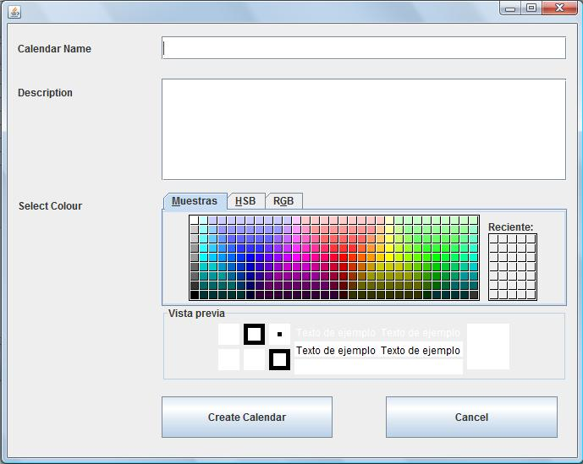
- User will get previous image and he will have to fill the information to create a calendar.
  - Calendar name: Is the name of the category, eg: University, Social, job...
  - Description: Is some details about category
  - Colour: Is the color that represents that category.
- Once information is filled user must click on Create Calendar button to save data.
- If eveything is correct, user will be able to see the new category created on the sidebar.

View just one category of appointments
To see appointments from one category an user must follow next steps:
- In the right sidebar different categories are shown, user must select or deselect them to see events from any category
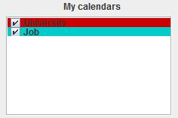
- To select or deselect one category an user only has to click on the checkbox at the left of each name.
  - Tick is selected and events of that category are shown
  - No tick is unselected and events of that category are hidden
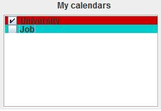
- For example, imaging previous image user will only see University appointments.

